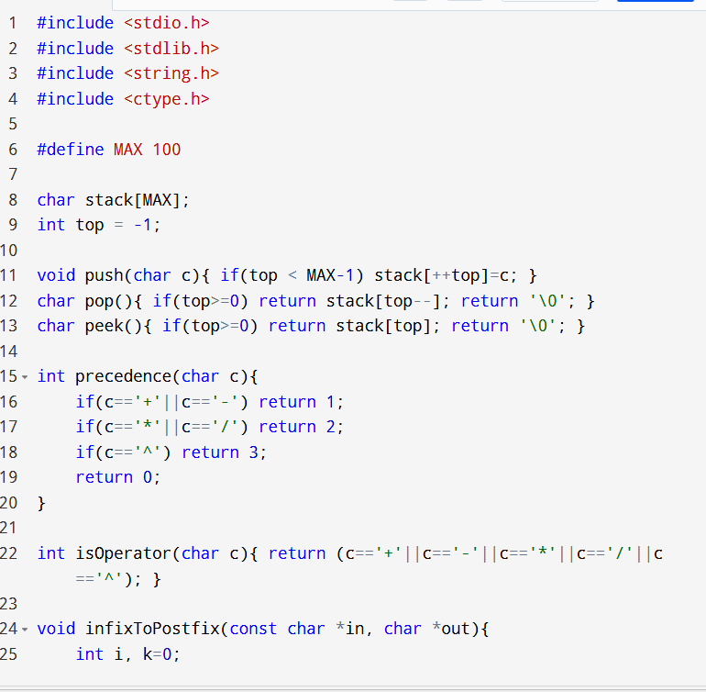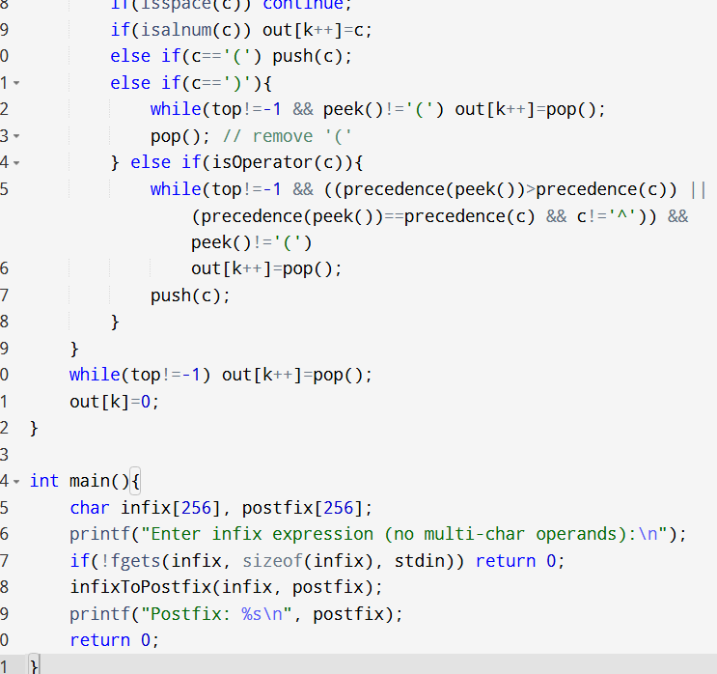

**OUT PUT:**

